# Lab: JavaScript Syntax and Operators

Problems for in-class lab for the ["JavaScript Fundamentals" course @ SoftUni](https://softuni.bg/trainings/2247/js-fundamentals-january-2019)   
Submit your solutions in the SoftUni judge system at <https://judge.softuni.bg/Contests/Practice/Index/1421>

## String Length

Write a JS function that takes **three** **string arguments** as an input.

Calculate the sum of the lengths of the strings and the average length of the strings **rounded** down to its nearest integer.

The **input** comes as **three string arguments** passed to your function.

The **output** should be printed to the console in two rows.

### Examples

|  |  |
| --- | --- |
| **Input** | **Output** |
| 'chocolate', 'ice cream', 'cake' | 22  7 |

|  |  |
| --- | --- |
| **Input** | **Output** |
| 'pasta', '5', '22.3' | 10  3 |

### Hints

* Write your function which receives three string arguments.
* Declare two variables named **sumLength** and **averageLength** that will keep your results from mathematical logic.
* Now you need to calculate the lengths of the strings using the **length property**.

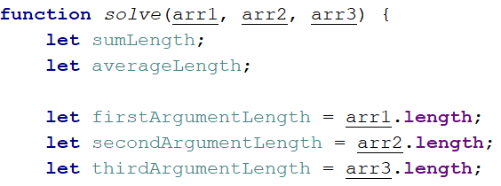

* Calculate the sum of the three lengths.



* Calculate the average length of the strings **rounded** down to its nearest integer. To do this use the Math.floor() function.



* And the last thing you have to do is print the two results on the console.

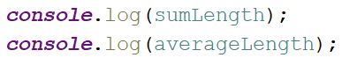

## Math Operations

Write a JS function that takes **two** **numbers** and **a string** as an input.

The string may be one of the following: '+', '-', '*', '/', '%', '**'.

Print on the console the result of the mathematical operation performed by both numbers and the mathematical operator you receive as a string.

The **input** comes as **two numbers and a string argument** passed to your function.

The **output** should be printed to the console.

### Examples

|  |  |  |  |  |
| --- | --- | --- | --- | --- |
| **Input** | **Output** |  | **Input** | **Output** |
| 5, 6, '+' | 11 |  | 3, 5.5, '*' | 16.5 |

### Hints

* Write your function which receives three arguments:

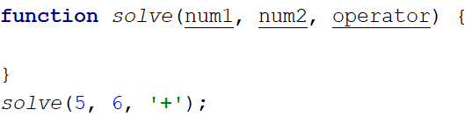

* Declare a variable named **result** that will keep your result from mathematical logic.
* Now you need to write down your switch command that will take the string from your input and depending on it, perform the mathematical logic between the two numbers.

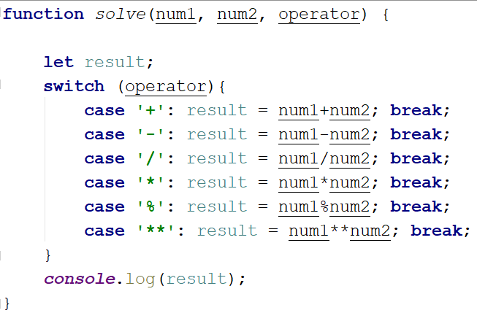

* The last step is to print your result on the console.



## Sum of Numbers N…M

Write a JS function that takes two numbers **n and m** as an input and prints the sum of all numbers from **n** to **m**.

The **input** comes as **two string elements** that need to be parsed as a number.

The **output** should be returned as a result of your function.

### Examples

|  |  |
| --- | --- |
| **Input** | **Output** |
| '1', '5' | 15 |

|  |  |
| --- | --- |
| **Input** | **Output** |
| '-8', 20' | 174 |

### Hints

* Write your function which receives two number arguments.
* As you know, you receive two strings that need to be parsed as a number. There are two ways to do this: use Number(string) function or just put the '+' sign before the string.

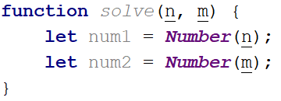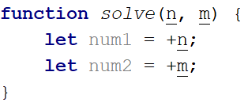

* Declare a variable named **result** that will keep your results from mathematical logic.
* Write a for loop from num1 to num2 and for every turn of the cycle, until its completion, add the current value.

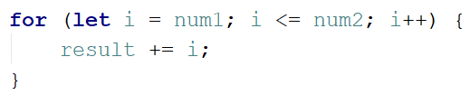

* At the end, return the result.



## Largest Number

Write a JS function that takes **three number arguments** as an input and find the largest of them. Print the following text on the console: 'The largest number is {number}.'.

The **input** comes as **three number arguments** passed to your function.

The **output** should be printed to the console.

### Example

|  |  |
| --- | --- |
| **Input** | **Output** |
| 5, -3, 16 | The largest number is 16. |
| **Input** | **Output** |
| -3, -5, -22.5 | The largest number is -3. |

### Hints

* Write your function which receives three number arguments.
* Declare a variable named **result** that will keep your results from mathematical logic.

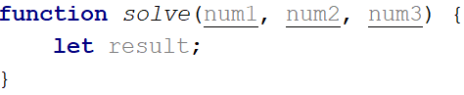

* It is now necessary to make several checks to find out the largest of the three numbers. Start with num1.

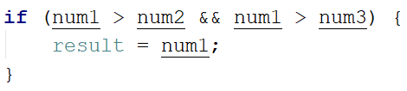

* Do the same for the others.

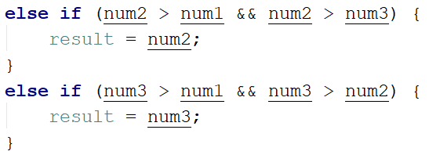

* The last thing you need to do is to print the result on the console.



## 5. Circle Area

Write a JS function that takes **a single argument** as an input.

Check the type of the input argument. If it is a number, assume it is the radius of a circle and calculate the circle area. Print the area **rounded** to two decimal places.

If the argument type is different than a number, print the following text on the console: 'We cannot calculate the circle area, because we receive a {type of argument}.'

The **input** comes a **single argument** passed to your function.

The **output** should be printed to the console.

### Example

|  |  |  |  |  |
| --- | --- | --- | --- | --- |
| **Input** | **Output** |  | **Input** | **Output** |
| 5 | 78.54 |  | 'name' | We can not calculate the circle area, because we receive a string. |

### Hints

* Write your function which receives a single argument.
* Declare a variable named **result** that will keep your result from mathematical logic.

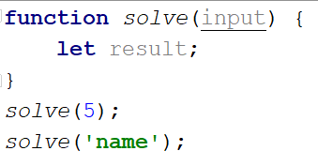

* Now check the type of the input argument with **typeof ()**.



* You need to formulate your logic. If the type is equal to 'number', calculate the circle area and print it on the console rounded to two decimal places.  
   To do this, use the method toFixed().  
   The Math.pow() function returns the base to the exponent power, that is, base exponent. You can find more information about the area [here](https://en.wikipedia.org/wiki/Circle):

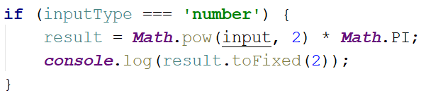

* If the type is different from 'number', you have to print the following text on the console:

